Your human rights and how to make a complaint

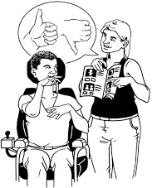

A guide for disabled people and families

Easy Read Version


What are human rights?

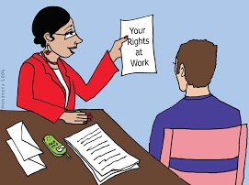
Everyone has human rights.

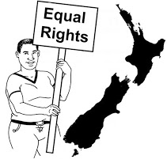
This means that you have the right to be treated well and the same way as other New Zealanders.

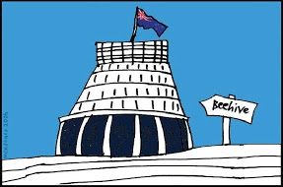
Human rights are also about how the government should treat you as a New Zealander.

Human rights are about people being:
- safe and cared for
- making their own decisions
- having a good life
- being included in the community and society.

What if my rights are not being respected?

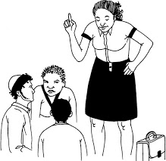
If you feel like someone has treated you differently because of your disability you can do something about it.

This information will tell you about:


- how to make a complaint to the Human Rights Commission
- what will happen if you make a complaint
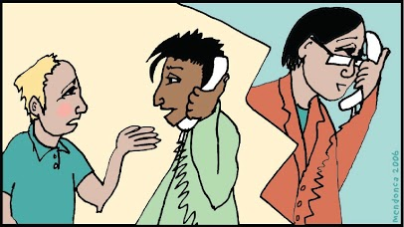
- general information about making a complaint
- other places that might be able to help you if you have a complaint.

How does the New Zealand government make sure I have human rights?

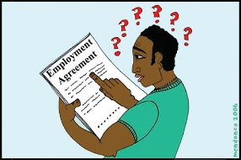
In New Zealand your human rights are in place within:
- New Zealand laws
and
- international agreements.

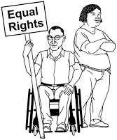
The rights of disabled people are in the:
- United Nations Convention on the Rights of Persons with Disabilities/ The Disability Convention
- Human Rights Act
- other laws.

The Disability Convention

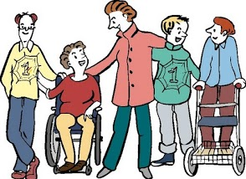
The Disability Convention is about disabled people’s human rights.

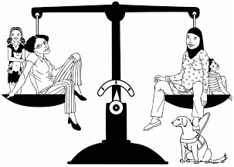
Disabled people have the same rights as everyone else.

The Disability Convention says disabled people include people with long term:
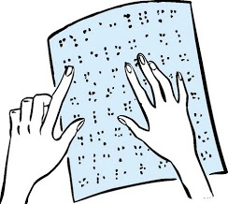
- physical disabilities
- experience of mental illness
- intellectual/ learning disability
- sensory disabilities like being blind or deaf.

The New Zealand government has agreed to make sure the goals in the Disability Convention happen.
The Human Rights Act

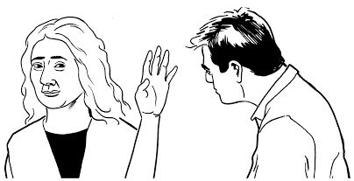
If you are treated unfairly because of your disability this is called discrimination.
Discrimination is against the law.
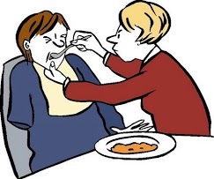
The Human Rights Act protects you from being discriminated against because of your disability.
The Act covers:
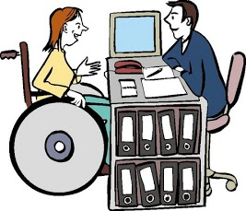
- the government or any of its services
- when trying to get a job
- when being in business with someone else
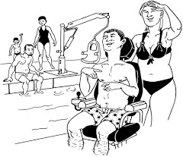
- in education: kindergarten, school, polytech, university or any other learning place
- public places
- transport services like buses and taxis
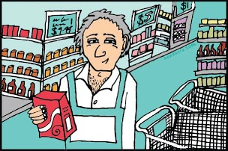
- buildings that people in the community use
- when buying new things

- when getting services
- where and how you live
- places that do training and give out qualifications.

The Human Rights Act also says that people are not allowed to discriminate against someone because of:

- being a man or a woman
- being single or married or living with a partner

- your religion
- what you believe in
- the colour of your skin
- where you come from
- your age (if you are 16 years and older)
- who you choose for the government
- your family
- being gay, lesbian, bi- sexual, transgender.

The Human Rights Act also protects you from sexual or racial harassment.

There are different ways that people might discriminate against you because of your disability.
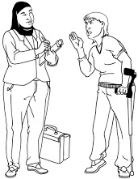
- People might say you can’t have a job on the front desk because you have a brace on your leg and they don’t want a disabled person on reception.

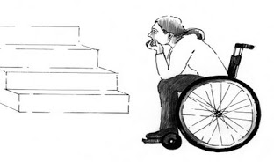
- You might not be able to go into a shop because the only way to get in is by going up the stairs and you can’t walk up stairs because of your disability.

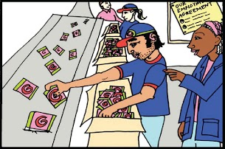
People might discriminate against you because:
- you have a disability
- you have had a disability in the past
- people just think you have a disability.
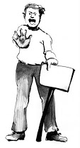
It is also against the law for someone to discriminate against your family or friends because of the disabled person.

Here is an example of when someone was discriminated against.

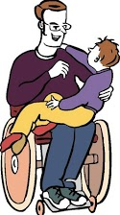
A family with their disabled child go to a restaurant.
The restaurant lets the family with their disabled child drink in the garden bar but does not let them use the family room like other families with children.

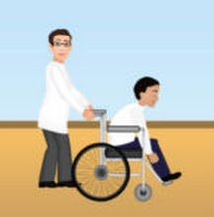
The family with the disabled child are not being given the same rights as the other families. This means they are being discriminated against because of their disabled child.

What does the Human Rights Commission do?

The Human Rights Commission:
- tells New Zealanders about their human rights
- looks after New Zealanders human rights
- takes complaints when people say they have been discriminated against
- watches to make sure New Zealanders get their human rights.

The Government gives the Human Rights Commission the funding to do the work but the Human Rights Commission is not part of the government.

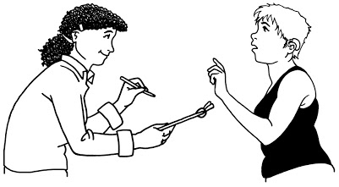
An important part of the Human Rights Commission’s work is to make sure human rights keep getting better for New Zealanders.
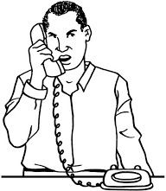
The Human Rights Commission has a team of people who work in the area of disability.

Their team leader is the DisabilityRights Commissioner.

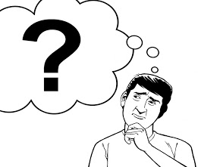
The DisabilityRights Commissioner makes sure hat disabled people don’t have their rights taken away.

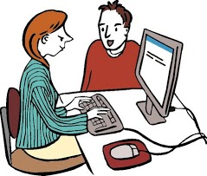
When the Commissioner finds problems he or she must:
- find some answers to the problem to make sure it doesn’t happen again in the future.

What can I talk to the Human Rights Commission about?

You can contact the Human Rights Commission if you think that:
- your rights are not being respected
- you are being discriminated against.

You can contact the Human Rights Commission to:

- tell us about a problem you have had where you feel your rights were not respected and we will write it down
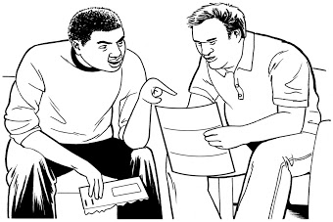
- talk about a situation that you might be worried about where your rights were not respected. We will talk about different ways it can be sorted out
- get information and advice about your rights
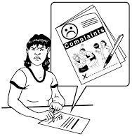
- make a complaint if you feel you have been discriminated against because of your disability.

You can contact us if you are a family member or friend of someone who wants to make a complaint. But you must have their permission.

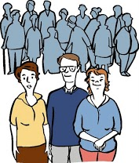
You can also make a complaint for a group of people.

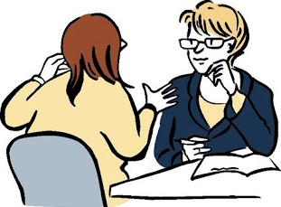
You should not get in trouble because you have made a complaint or supported someone else to make a complaint.

What do I do if I’m not happy with how I have been treated?

It is your right to:
- make a complaint
- get an answer about the complaint you made.

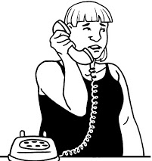
It is good to speak up when you are not happy about something.

When you speak up and make a complaint it means that you can get help to get the problem sorted.
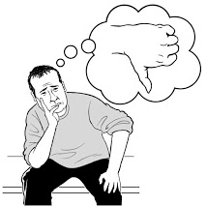
It can be hard to speak up.

It can be hard to figure out what to say and who to say it to.
Information to help you make a complaint



Here is some information to help you make a complaint.

Before making a complaint:

- talk to someone you trust
- be very clear about what the complaint is about
- take notes about what happened
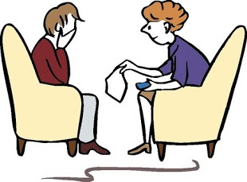
- think about what made you unhappy and what would make it better for you
- think about what kind of support you will need.


It is helpful to have someone help you make a complaint.

This person can help you:
- put your complaint in writing
- by going to meetings with you.

Someone who could help could be:
- family/ whānau
- friend
- advocate.

Who should I make my complaint to?

If you feel safe to, talk to the person you are unhappy with first.

Sometimes this can sort out the problem.
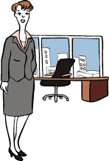

If you don’t feel safe speaking to the person or weren’t happy with the answer talk to their Manager or supervisor.
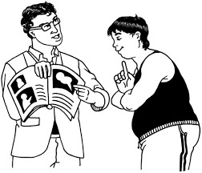
If you are making a complaint within an organisation or service ask them to tell you about their complaints system.

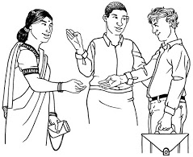
They will tell you who to contact and how to make a complaint.

What should I say in my complaint?

Try and make the complaint as soon as you have a problem.

You can make a complaint:

- by writing a letter
- by writing an email
- by saying it face to face
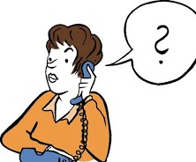
- by saying it over the telephone.

Remember when you make a complaint to:
- make sure you say that you are making a complaint
- put your name and contact details
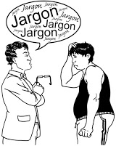
- say what happened, when it happened and why you are not happy

- put in any other information about your complaint
- tell them how you want your complaint to be sorted For example: do you want an apology? Do you want who you are complaining about to do something?

It is important to be realistic about what you want to happen.


If you have a meeting to talk about your complaint or talk over the telephone write down:

- the name of the person you talk to

- the date and the time that you had the conversation
- the main points of what the other person said.

Ask the person who takes your complaint:
- to write to you to say they have received your complaint
- when you will hear back from them about your complaint.
If you are emailing or posting in your complaint:
- keep a copy for yourself
- write down the date you sent it.
What if I want to make a complaint to the Human Rights Commission?

You can make a complaint to the Human Rights Commission by:
- free phone: 0800 496 877
- fax: 09) 377 3593 and write in subject line: Attention: infoline
- email: infoline@hrc.co.nz
- go to the Human Rights Commission website and use the online form
- if you are deaf or have a hearing or speech disability you can use the New Zealand Relay Service at www.nzrelay.co.nz
- Language Line: this is where you can get someone to help if you speak another language
- New Zealand Sign Language Interpreters- you have to ask for this

It is free to contact the Human Rights Commission.

You do not need a lawyer.

The Human Rights Commission have staff who know a lot about disability rights and they can help you with your complaint.

What you say to us will be kept private.

What happens when I make a complaint to the Human Rights Commission?

The Human Rights Commission will:
- listen to your complaint and ask questions to find out all the information and understand what you want to happen
- talk to you about different ways to sort out the problem
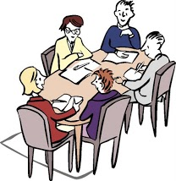
- say if the Human Rights Commission cannot help you with your complaint. Tell you why and help you to contact the right place to sort out your complaint.

How can the Human Rights Commission help sort out my complaint?

The Human Rights Commission can help you sort out your complaint by:
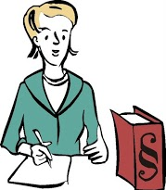
- giving you information and advice on your rights so you can try and sort out the problem yourself
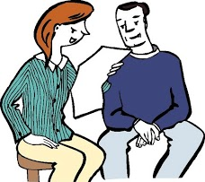
- contact the person/ people you have a complaint about to talk about your complaint with them
host a meeting between you and the person/ people involved in the complaint. This is called mediation.
What is mediation?

Mediation is when someone helps you have a meeting with the person/ people you made a complaint about.
This person is called a Mediator.
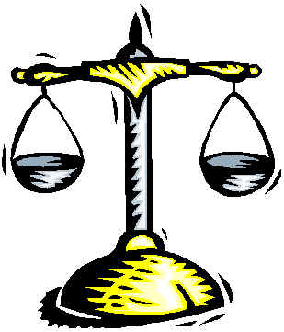
The Mediator is not on anyone’s side.
The Mediator helps everyone to talk about the complaint in a fair, open and helpful way.

The Mediator helps people to understand each other’s point of view and the problems being talked about.

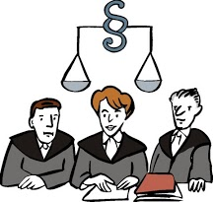
During mediation you might talk about the Human Rights Act and find some ways to sort out the complaint.
Ways to sort out the complaint might be:
- an apology to the person who made the complaint

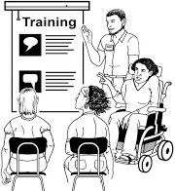
- agreeing to put staff through a training course about an issue


- the person who made the complaint getting some money to say sorry for having their feelings hurt.

Mediation is:
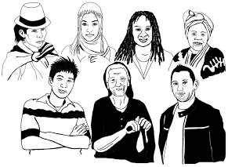
- free
- can be done differently to suit the people and the situation
- private.
You don’t have to meet with the person/ people you made a complaint about through mediation if you don’t want to.
Mediation can be done by:
- letters
- phone calls
- videoconferencing
- face to face meeting.
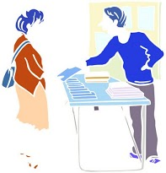
The Mediator will make sure you know what will happen and that you are comfortable with what is happening.
If there needs to be a meeting the Mediator will arrange it.

The Mediator will ask you what you need to take part in the meeting:
- a meeting room that you can use
- a New Zealand Sign Language Interpreter
- a language interpreter if English is your second language
- regular rest breaks
Do complaints get sorted out with mediation?

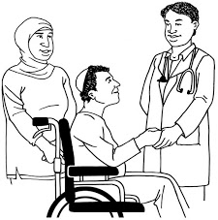
Yes, complaints are usually sorted out through mediation.

The goal of mediation is to reach an answer that all people are happy with.

What happens if my complaint is not sorted out with mediation?

If your complaint can’t be sorted out then you can take it to the Human Rights Review Tribunal.

The Human Rights Review Tribunal is like a court.

It can listen to people complaints and make a decision about what should happen.
The Human Rights Review Tribunal:
- is not part of the government or the Human Rights Commission
- can say if it thinks the person who made a complaint gets paid out any money
- can say other things must happen like having to say sorry to the person.


The Human Rights Review Tribunal’s decision is final.

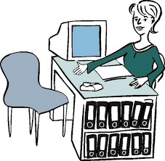
You can sometimes get free legal help if you go to the Human Rights Review Tribunal from the Human Rights Commission.

What if I am not happy with how the Human Rights Commission dealt with my complaint?

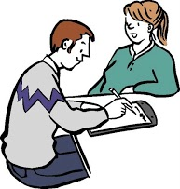
If you are unhappy with how the Human Rights Commission dealt with your complaint you should talk to the Mediator.

If you are still not happy or don’t want to talk to the Mediator you can talk to the Commission’s Chief Mediator.

You also have the right to talk to the Office of the Ombudsman and ask them to look at how the Human Rights Commission handled your complaint.

Who else can I make a complaint to?

Health and Disability Commissioner
If you are unhappy with how a health or disability service was provided
 | Free phone | 0800 11 22 33
 | Email | hdc@hdc.org.nz
 | Website | www.hdc.org.nz
Health and Disability Advocates
Health and Disability Advocates can help you with a complaint about a health or disability service
Free phone 0800 55 50 50
Website http://advocacy.hdc.org.nz/

The Office of the Ombudsman
For complaints about government departments and Councils. It includes complaints about ACC payments, benefits, education, housing and health.
 | Free phone | 0800 802 602
 | Email | info@ombudsman.parliament.nz
 | Website | www.ombudsman.parliament.nz

The Privacy Commissioner
If you think someone has not respected your privacy rights
 | Free phone | 0800 803 909
 | Email | enquiries@privacy.org.nz
 | Website | www.privacy.org.nz
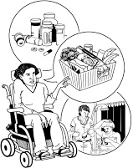
All of these different places deal with different kinds of complaints.

If one of the places can’t help you they should be able to tell you where to go to get your complaint heard.

If you don’t know who to tell your complaint to, call the Human Rights Commission InfoLine (0800 496 877) and someone will answer and help you work out where to go to make your complaint.


There is a website that has information about where to make your complaint to: www.complaintline.org.nz
For any more information call the Human Rights Commission.

Human Rights Commission InfoLine

If you have any questions about your human rights or want to make a complaint:
 | Free phone | 0800 496 877
 | Fax | 09 377 3593
 | Email | infoline@hrc.co.nz
 | Website | http:/www.hrc.co.nz
 | Language line | Available
 | New Zealand Sign Language Interpreters | Available
 | New Zealand Relay Service | www.nzrelay.co.nz

Here are two stories about making a complaint

Story 1: Jenny misses out on her school camp
Jenny has an intellectual disability.

Jenny’s class is going on camp but they don’t want Jenny to go.
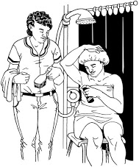
The school says that Jenny needed one to one support and was also a safety risk.

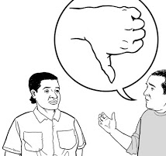
Jenny’s parents were not happy.

The school did not talk to Jenny’s parents before they made the decision not to let Jenny go to camp.

Jenny’s parents made a complaint to the Human Rights Commission.

The school and Jenny’s parents had mediation- a meeting to talk about the problem and what could be done to fix it.

The school and Jenny’s parents had a good talk and agreed that things had not been done well.
They agreed that they could have worked together to find a way that Jenny could go to camp like one of Jenny’s parents going with her.

Jenny didn’t get to go to her camp but they were able to make changes so the same things didn’t happen again in the future for other disabled children in the school.

The school also agreed to check their policies or rules about children being outside of the classroom.

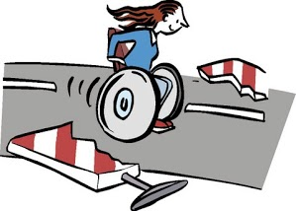
Story 2: A community service makes changes

Hannah uses a wheelchair.

Hannah went to one of the local services in her community.

The low counter where Hannah used to fill out her forms was gone.

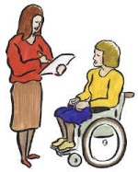

There was nowhere Hannah could fill out her forms anymore.

Hannah complained to the Human Rights Commission.
The Human Rights Commission talked to the service and they agreed to have a meeting.

They wanted to meet with Hannah so that they could understand what she needed when she came in to use their service.

They had another meeting so that Hannah could talk to them about serving disabled people into the future.


The service agreed to make changes in the reception areas so that there were low desks for disabled people.

The service has put in a low desk in the areas where Hannah goes.
Hannah was able to learn about the service’s disability training for staff.

The service asked Hannah to look at the training package and see if she could make any suggestions to make it better.

The service said sorry to Hannah and paid her some money to say sorry for the bad experience she had gone through.



This information has been translated into Easy Read
by People First New Zealand Inc.- Nga Tangata Tuatahi


